Steamboat Springs School District 2023-2024 Household Application for Free and Reduced-Price School Meals
Complete one application per household. Please use a black or blue pen (not a pencil).

Birth Date
M M D D Y Y
List ALL Students’ attending Steamboat Springs School District (if more spaces are required for additional names, attach another sheet of paper)

STEP 1
Grade
Foster Head
Child Start Runaway Homeless Migrant
MI
Student’s Last Name
Student’s First Name
Check all that apply. Read How to Apply for Free and Reduced-Price School Meals for more information.

If any household members (including you) currently receive assistance from any of the following programs: SNAP, TANF or FDPIR list the case number below.
If any household members (including you) currently receive assistance from any of the following programs: SNAP, TANF or FDPIR list the case number below.

STEP 2
Supplemental Nutrition Assistance Program (SNAP), Temporary Assistance for Needy Families (TANF/Colorado Works – Basic Cash Assistance or State Diversion), or Food Distribution Program on Indian Reservations (FDPIR). Provide case number and skip to Step 4.

FDPIR Case Number
TANF Case Number
SNAP Case Number
Report income for ALL household members (skip this step if you provided a case number in STEP 2)

STEP 3
How Often?
Student Income
- Student Income
Please include the TOTAL income, if any, received by all students listed above.
$
Weekly | Bi-Weekly | 2x Month | Monthly | Annually

- All Other Household Members (including yourself)
In the spaces below list all other household members not listed in Step 1 (including yourself) even if they do not receive income. For each household member listed, if they do receive income, report TOTAL GROSS INCOME (BEFORE TAXES AND OTHER DEDUCTIONS) for each source in whole dollars only. If they do not receive income from any source, write ‘0’. If you enter ‘0’ or leave any fields blank, you are certifying that there is no income to report.

Pensions/Retirement/
All Other Income
How Often?
Public Assistance/
Child Support/Alimony
Names of All Other Household Members
(First and Last)
Weekly | Bi-Weekly | 2x Month | Monthly | Annually

How Often?
$
$
$
$
$
$
$
$
$
$
$
$
Weekly | Bi-Weekly | 2x Month | Monthly | Annually

How Often?
Earnings from Work
Weekly | Bi-Weekly | 2x Month | Monthly | Annually

Check box if no SSN
XXX-XX-
Last four digits of Social Security Number (SSN) or mark “no SSN” of adult signing this form only if Step 3B has been completed.
Total Household Members
(Students’ and Adults from Steps 1 and 3)

STEP 4
“I certify (promise) that all information on this application is true and that all income is reported. I understand that this information is given in connection with the receipt of Federal funds, and that school officials may verify (check) the information. I am aware that if I purposely give false information, my children may lose meal benefits, and I may be prosecuted under applicable State and Federal laws.”
Contact information and adult signature. Mail signed and completed application to: 325 7th St, Steamboat Springs, CO 80487

CO
Mailing Address or PO Box
Apt. # or Lot #
City
State
Zip Code
Email Address

STEP 5 Release of Information
Today’s Date
Printed First and Last Name of Signer
SIGNATURE of Adult Household Member (Required)
Home or Cell Phone Number
The information provided on this application will be used in conjunction with state educational programs and may be shared with Medicaid or State Children’s Health Insurance Program (SCHIP) offices. If your students are eligible to receive free or reduced-price meals this information may be shared with the school/district for purposes of waiving school/district program fees that your child(ren) might otherwise be required to pay. The school/district is not permitted to share your information with anyone else. You are not required to consent to the release of your information; this will not affect your student(s) eligibility for school meals. Your information WILL be shared unless you check one of the boxes below.

Do NOT share my information with the programs I have checked:
Do NOT share my information
with any programs
Accelerate College Opportunity Exam and/or Book Fees

Advanced Placement (AP) Exam and/or (AP) Book Fees
See back of application
Medicaid/SCHIP
We are required to ask for information about your children’s race and ethnicity. This information is important and helps to make sure we are fully serving our community. Responding to this section is optional and does not affect your children’s eligibility for free or reduced-price meals. This information is requested solely for the purpose of determining the State’s compliance with Federal civil rights laws, and your response will not affect consideration of your application and may be protected by the Privacy Act. By providing this information, you will assist us in assuring that this program is administered in a nondiscriminatory manner. If the applicant declines to self-identify, identification of his or her race and ethnicity will be made using district records or visual identification and recorded in the data system.
OPTIONAL Children’s Racial and Ethnic Identities

Not Hispanic or Latino
Hispanic or Latino
Ethnicity (check one):
White
Native Hawaiian or Other Pacific Islander
Black or African American
Asian
American Indian or Alaskan Native
Race (check one or more):
Colorado PEAK is an online service for Coloradans to screen and apply for medical, food and cash assistance programs.

Visit coloradopeak.force.com to learn more.
You may also qualify for the Supplemental Nutrition Assistance Program! See more information below.
DISTRICT USE ONLY. DO NOT WRITE BELOW THIS LINE.
Annual Income Conversion: Weekly x 52; Bi-Weekly x 26; 2 Times per Month x 24; Monthly x 12
Application Type:   Total Household Income: $ Household Size:_  Household Income Frequency -  Weekly  Bi-Weekly  2x/Month Monthly Annually  Categorical Eligibility - SNAP FDPIR TANF Foster  Homeless/Migrant/Runaway/Head Start | Application Status:  Approved - Free Reduced  Denied - Over Income Guidelines Incomplete/Missing: Notes:
Determining Official Signature: Approval/Denial Date: Notification Sent:
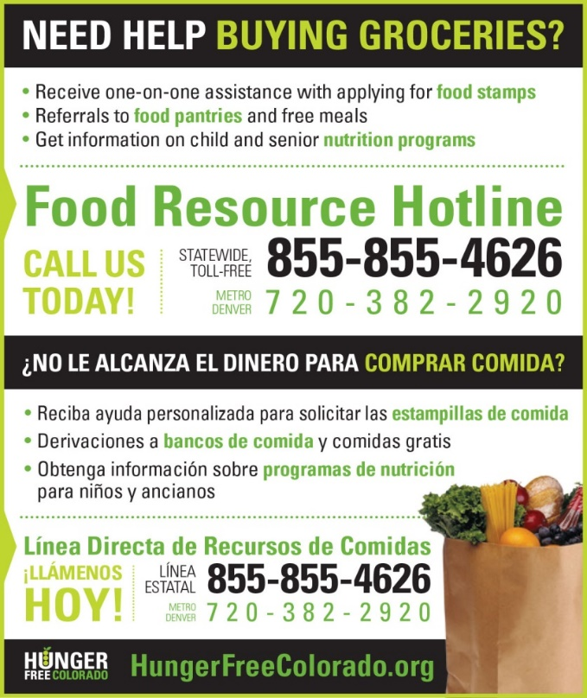
The Richard B. Russell National School Lunch Act requires the information on this application. You do not have to give the information, but if you do not submit all needed information, we cannot approve your child for free or reduced price meals. You must include the last four digits of the social security number of the primary wage earner or other adult household member who signs the application. The social security number is not required when you apply on behalf of a foster child or you list a Supplemental Nutrition Assistance Program (SNAP), Temporary Assistance for Needy Families (TANF) Program or Food Distribution Program on Indian Reservations (FDPIR) case number or other FDPIR identifier for your child or when you indicate that the adult household member signing the application does not have a social security number. We will use your information to determine if your child is eligible for free or reduced price meals, and for administration and enforcement of the lunch and breakfast programs. We may share your eligibility information with education, health, and nutrition programs to help them evaluate, fund, or determine benefits for their programs, auditors for program reviews, and law enforcement officials to help them look into violations of program rules.

