Steamboat Springs 2021-2022 Solicitud del hogar para comida escolar gratuita y de precio reducido
Llene una solicitud por hogar. Por favor usa una pluma negra o azul (no lápiz).
PASO 1
Mencione a todos los estudiantes que asisten Steamboat Springs School District (si necesita más espacios para nombres adicionales, adjunte otra hoja)

Fecha de nacimiento
M M D D A A
Niño de Head Bajo Custodia
Acogida Start Temporal Sin Hogar Migrante
Apellido del estudiante
Inicial
Nombre del estudiante
Grado
Marque todas las que apliquen. Lea Cómo solicitar comida escolar gratuita y de precio reducido para más información.

PASO 2

Si algún miembro del hogar (incluido usted) actualmente recibe asistencia de cualquiera de los siguientes programas: SNAP, TANF o FDPIR enumeran el número de caso a continuación.

Programa de Asistencia Nutricional Suplementaria (SNAP), Asistencia Temporal para Familias Necesitadas (TANF/Colorado Works – Asistencia Básica en Efectivo o Asistencia Alternativa Estatal), o Programa de Distribución de Alimentos en Reservas Indígenas (FDPIR). Provea el número de caso y vaya al Paso 4.

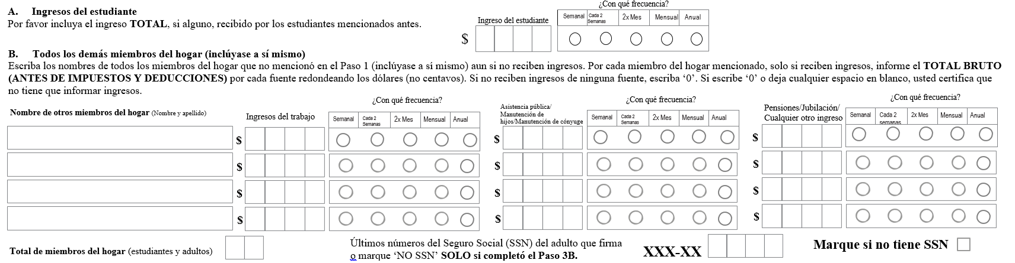
Número de caso FDPIR
Número de caso TANF
Número de caso SNAP
Informe el ingreso de TODOS los miembros del hogar (omita este paso si proporcionó un número de caso en el PASO 2)

PASO 3

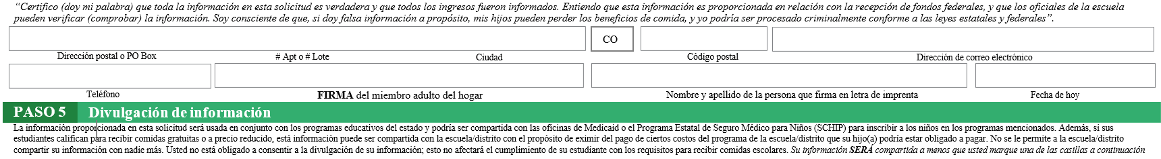
PASO 4 Información de contacto y firma del adulto. Envíe la solicitud firmada y completa a: Steamboat Springs School District 325 7th St. 80487

List Specific Program

List Specific Program

List Specific Program
Medicaid/SCHIP
No compartan mi información con los programas que marqué:
NO compartan mi información con ninguno de los programas
Ver atrás de la aplicación

OPCIONAL Identidad racial y étnica de los niños
Tenemos que pedir información sobre la raza y etnia de sus hijos. Esta información es importante y nos ayuda a asegurarnos de que estamos sirviendo plenamente a nuestra comunidad. Responder a esta sección es opcional y no afecta el cumplimiento de su hijo con los requisitos para comida gratuita o de precio reducido.

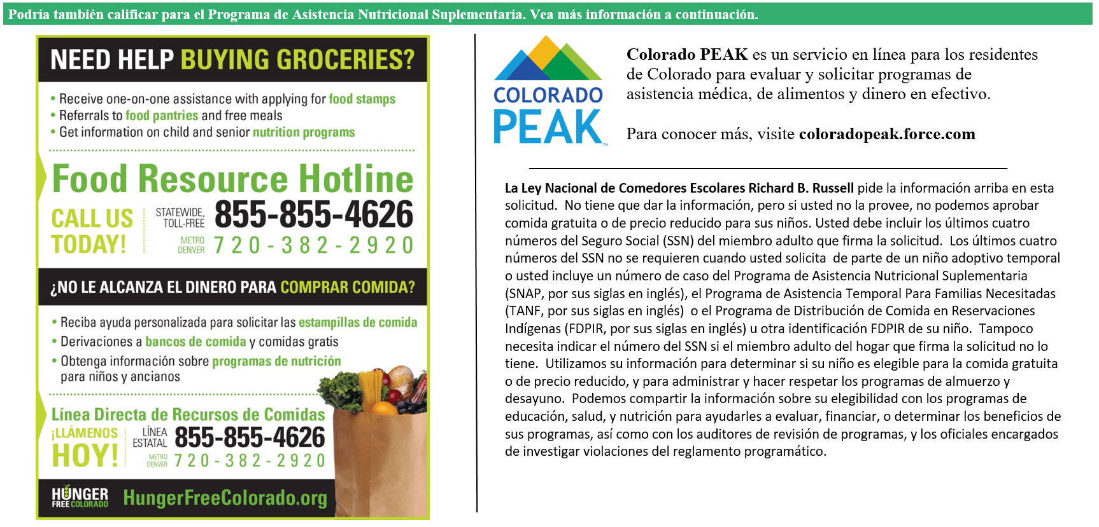
Ni hispano ni latino
Hispano o latino
Etnica (marque una):
Blanco
Nativo de Hawái u otra isla del Pacífico
Negro o afroamericano
Asiático
Indio americano o nativo de Alaska
Raza (marque una o más):
NO ESCRIBA DEBAJO DE ESTA LÍNEA. SOLO PARA USO DEL DISTRITO
Annual Income Conversion: Weekly x 52; Bi-Weekly x 26; 2 Times per Month x 24; Monthly x 12
Application Type:   Total Household Income: $ Household Size:_  Household Income Frequency -  Weekly  Bi-Weekly  2x/Month Monthly Annually  Categorical Eligibility - SNAP FDPIR TANF Foster  Homeless/Migrant/Runaway/Head Start | Application Status:  Approved - Free Reduced  Denied - Over Income Guidelines Incomplete/Missing: Notes:
Determining Official Signature: Approval/Denial Date: Notification Sent:

